
1110 Brickell Avenue, Seventh Floor
Miami, Florida 33131
(305) 372-1350

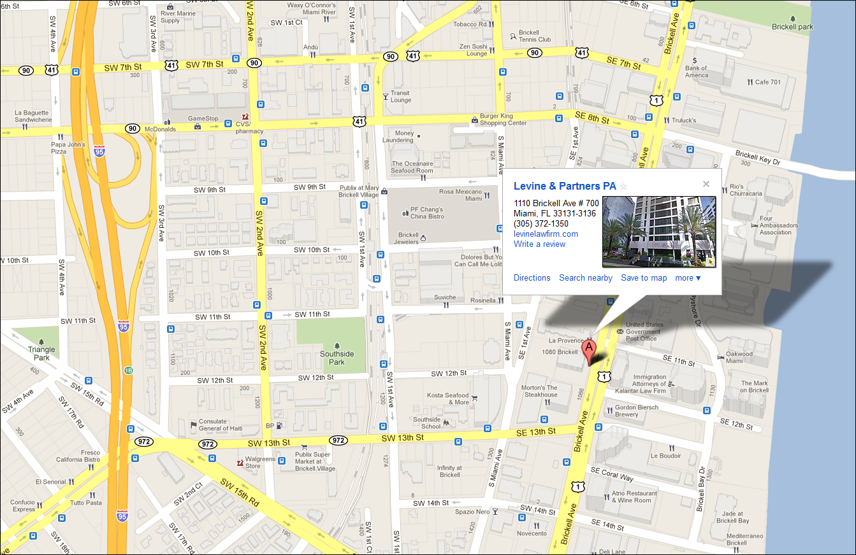

TRAVELING TO LEVINE & PARTNERS, P.A. FROM THE NORTH:
TAKE I-95 SOUTH TO MIAMI. FOLLOW SIGNS FOR "DOWNTOWN". EXIT I-95 AT EXIT #1B (S.W. 7TH STREET ON THE RIGHT-HAND SIDE OF THE HIGHWAY.). AT THE SECOND TRAFFIC LIGHT MAKE A LEFT ONTO S.W. 8TH STREET AND TRAVEL 6/10 OF A MILE TO BRICKELL AVENUE. MAKE A RIGHT ONTO BRICKELL AVENUE AND TRAVEL 2/10 OF A MILE (3 BLOCKS) TO 1110 BRICKELL. ENTER VISITOR PARKING ON NORTH SIDE OF BUILDING.

TRAVELING FROM LEVINE & PARTNERS, P.A. TO THE NORTH:
EXIT VISITOR PARKING AND TURN RIGHT ONTO BRICKELL AVENUE. MAKE YOUR FIRST RIGHT ONTO S.E. 13TH STREET (A/K/A CORAL WAY). GO 1 BLOCK AND TURN RIGHT ONTO SOUTH MIAMI AVENUE BEARING TO THE LEFT AT THE FORK AND CONTINUING 3/10 OF A MILE TO S.W. 7TH ST. MAKE A LEFT ONTO S.W. 7TH STREET. TRAVEL 4/10 OF A MILE TO S.W. 4TH AVENUE AND TURN LEFT ONTO S.W. 4TH AVENUE. GO 1 BLOCK AND MAKE A LEFT ONTO S.W.8TH ST. BEAR TO THE RIGHT LANE AND ENTER I-95 NORTH BOUND RAMP.

TRAVELING TO LEVINE & PARTNERS, P.A. FROM THE SOUTH:
TAKE US-1 (SOUTH DIXIE HIGHWAY) TO I-95 NORTH. EXIT #2 (US-41) TOWARDS S.W. 8TH STREET/BRICKELL AVENUE. TURN RIGHT AT THE FIRST LIGHT ONTO S.W. 8TH STREET (CALLE OCHO) AND PROCEED TO BRICKELL AVE (APPROX. 6/10 OF A MILE). MAKE A RIGHT ONTO BRICKELL AVENUE AND TRAVEL 2/10 OF A MILE (3 BLOCKS) TO 1110 BRICKELL. ENTER VISITOR PARKING ON NORTH SIDE OF BUILDING.

TRAVELING FROM LEVINE & PARTNERS, P.A. TO THE SOUTH:
EXIT VISITOR PARKING AND TURN RIGHT ONTO BRICKELL AVENUE, CONTINUING SOUTH TO U.S. 1 (SOUTH DIXIE HIGHWAY).

TRAVELING TO LEVINE & PARTNERS, P.A. FROM
SOUTH MIAMI BEACH:
TAKE MACARTHUR CAUSEWAY (I-395) WEST ONTO I-95 SOUTH. TAKE I-95 SOUTH, FOLLOWING SIGNS FOR "DOWNTOWN". EXIT I-95 AT EXIT #1B (S.W. 7TH STREET ON THE RIGHT-HAND SIDE OF THE HIGHWAY.). AT THE SECOND TRAFFIC LIGHT MAKE A LEFT ONTO S.W. 8TH STREET AND TRAVEL 6/10 OF A MILE TO BRICKELL AVENUE. MAKE A RIGHT ONTO BRICKELL AVENUE AND TRAVEL 2/10 OF A MILE (3 BLOCKS) TO 1110 BRICKELL. ENTER VISITOR PARKING ON NORTH SIDE OF BUILDING.

TRAVELING FROM LEVINE & PARTNERS, P.A. TO
SOUTH MIAMI BEACH:
EXIT VISITOR PARKING AND TURN RIGHT ONTO BRICKELL AVENUE. MAKE YOUR FIRST RIGHT ONTO S.E. 13TH STREET (A/K/A/ CORAL WAY). GO 1 BLCOK AND TURN RIGHT ONTO SOUTH MIAMI AVENUE BEARING TO THE LEFT AT THE FORK, CONTINUING 3/10 OF A MILE TO S.W. 7TH ST. MAKE A LEFT TURN ONTO S.W. 7TH STREET. TRAVEL 4/10 OF A MILE TO S.W. 4TH AVENUE. GO 1 BLOCK AND MAKE A LEFT ONTO S.W. 8TH ST. BEAR TO THE RIGHT LANE AND ENTER - I-95 NORTH BOUND RAMP. TAKE I-95 NORTH TO I-395 EAST.

TRAVELING TO LEVINE & PARTNERS, P.A. FROM
CENTRAL MIAMI BEACH:
TAKE AURTHUR GODFREY ROAD OR ALTON ROAD TO 195 WEST. TAKE 195 TO I-95 SOUTH. I-95 SOUTH. FOLLOW SIGNS FOR "DOWNTOWN', EXIT I-95 AT EXIT #1B (S.W. 7TH STREET ON THE RIGHT-HAND SIDE OF THE HIGHWAY.). AT THE SECOND TRAFFIC LIGHT, MAKE A LEFT ONTO S.W. 8TH STREET AND TRAVEL 6/10 OF A MILE TO BRICKELL AVENUE. MAKE A RIGHT ONTO BRICKELL AVENUE, AND TRAVEL 2/10 OF A MILE (3BLOCKS) TO 1110 BRICKELL. ENTER VISITOR PARKING ON NORTH SIDE OF BUILDING.

TRAVELING FROM LEVINE & PARTNERS, P.A.
TO CENTRAL MIAMI BEACH:
EXIT VISITOR PARKING AND TURN RIGHT ONTO BRICKELL AVENUE. MAKE OUR FIRST TURN ONTO S.E. 13TH STREET (A/K/A/ CORAL WAY). GO 1 BLOCK AND TURN RIGHT ONTO SOUTH MIAMI AVENUE, BEARING TO THE LEFT AT THE FORK, CONTINUING 3/10 OF A MILE TO S.W. 7TH ST. MAKE A LEFT ONTO S.W. 7TH STREET. TRAVEL 4/10 OF A MILE TO S.W. 4TH AVENUE AND TURN LEFT ONTO S.W. 4TH AVENUE. GO 1 BLOCK AND MAKE A LEFT ONTO S.W. 8TH ST. BEAR TO THE RIGHT LANE AND ENTER I-95 NORTH BOUND RAMP. TAKE I-95 NORTH TO 195 EAST TO MIAMI BEACH.

TRAVELING TO LEVINE & PARTNERS, P.A. FROM
FT. LAUDERDALE/HOLLYWOOD INTERNATIONAL AIRPORT:
EXIT AIRPORT FOLLOWING SIGNS FOR I-595 WEST. TAKE I-595 WEST TO I-95 SOUTH TO MIAMI, FOLLOIWNG SIGNS FOR "DOWNTWON". EXIT I-95 AT EXIT #2 (S.W. 7TH STREET ON THE RIGHT-HAND SIDE OF THE HIGHWAY.) AT THE SECOND TRAFIC LIGHT MAKE A LEFT ONTO S.W. 8TH STREET AND TRAVEL 6/10 OF A MILE TO BRICKELL AVENUE. MAKE A RIGHT ONTO BRICKELL AVENUE AND TRAVEL 2/10 OF A MILE (3BLOCKS) TO 1110 BRICKELL. ENTER VISITOR PARKING ON NORTH SIDE OF BUILDING.

TRAVELING FROM LEVINE & PARTNERS, P.A. TO
FT. LAUDERDALE/HOLLYWOOD INTERNATIONAL AIRPORT:
EXIT VISITOR PARKING AND TURN RIGHT ONTO BRICKELL AVENUE. MAKE YOUR FIRST RIGHT ONTO S.E. 13TH STREET (A/K/A CORAL WAY). GO 1 BLOCK AND TURN RIGHT ONTO SOUTH MIAMI AVENUE, BEARING TO THE LEFT AT THE FORK, CONTINUING 3/10 OF A MILE TO S.W. 7TH ST. MAKE A LEFT ONTO S.W. 7TH STREET. TRAVEL 4/10 OF A MILE TO S.W. 4TH AVENUE AND TURN LEFT ONTO S.W. 4TH AVENUE. GO 1 BLOCK AND MAKE A LEFT ONTO S.W. 8TH ST. BEAR TO THE RIGHT LANE AND ENTER I-95 NORTH BOUND RAMP. I-95 NORTH TO I-595 EAST, FOLLOWING SIGNS FOR AIRPORT EXIT.

TRAVELING TO LEVINE & PARTNERS, P.A. FROM
MIAMI INTERNATIONAL AIRPORT:
FOLLOW AIRPORT SIGNS TO LE JEUNE ROAD. PROCEED SOUTH ON LE JEUNE ROAD TO THE SR-836 EAST RAMP TO DOWNTOWN (I-95). TAKE I-95 SOUTH RAMP TOWARDS DOWNTOWN. MERGE ONTO I-95 SOUTH. EXIT I-95 AT EXIT #2 (S.W. 7TH STREET ON THE RIGHT-HAND SIDE OF THE HIGHWAY). AT THE SECOND TRAFFIC LIGHT MAKE A LEFT ONTO S.W. 8TH STREET AND TRAVEL 6/10 OF A MILE TO BRICKELL AVENUE. MAKE A RIGHT ONTO BRICKELL AVENUE AND TRAVEL 2/10 OF A MILE 93 BLOCKS0 TO 1110 BRICKELL. ENTER VISITOR PARKING ON NORTH SIDE OF BUILDING.

TRAVELING TO LEVINE & PARTNERS, P.A. FROM
MIAMI INTERNATIONAL AIRPORT:
EXIT VISITOR PARKING AND TURN RIGHT ONTO BRICKELL AVENUE. MAKE YOUR FIRST RIGHT ONTO S.E. 13TH STREET (A/K/A CORAL WAY). GO 1 BLOCK AND TURN RIGHT ONTO SOUTH MIAMI AVENUE, BEARING TO THE LEFT AT THE FORK, CONTINUING 3/10 OF A MILE TO S.W. 7TH ST. MAKE A LEFT ONTO S.W. 7TH STREET. TRAVEL 4/10 OF A MILE TO S.W. 4TH AVENUE AND TURN LEFT ONTO S.W. 4TH AVENUE. GO 1 BLOCK AND MAKE A LEFT ONTO S.W. 8TH ST. BEAR TO THE RIGHT LANE AND ENTER I-95 NORTH BOUND RAMP. TAKE I-95 NORTH TO SR-836 WEST RAMP TOWARDS AIRPORT/UM JACKSON MEDICAL CENTER. MERGE ONTO SR-836 WEST. TAKE THE NW 42ND AVENUE/NORTH LE JEUNE ROAD EXIT. MERGE ONTO NORTH LE JEUNE ROAD. FOLLOW SIGNS TO MIAMI INTERNATIONAL AIRPORT.

